
L. R. PUNSALAN AND ASSOCIATES
Engineering Consultants
www.lrpunsalan.com

Lauremar Building
1458 Newton Street, San Isidro
Makati City
+632 8844-9122 to 24
lrpa@lrpunsalan.com

Submitted to:
DESIGN COORDINATES, INC.


L. R. PUNSALAN AND ASSOCIATES is an ISO 9001:2015-certified company

6 July 2026

L.R. PUNSALAN & ASSOCIATES
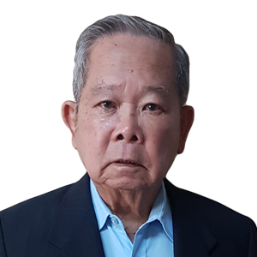
was established in 1974 by the Founding Partner, Engr. Laurentino R. Punsalan, FPME, in fulfillment of his desire and his associates to have a venue with which they could fully utilize their engineering background and specialized training and experience in the field of mechanical engineering designs and consultation works. Their previous long association with companies involved in systems application, contracting and servicing, and manufacturing have given them a well-rounded preparation necessary in their new undertaking.
Engr. Laurentino R. Punsalan
1932-2022

Since its establishment, the firm has accomplished a creditable number of engineering design and consultancy services, notably in its specialty line of air conditioning, ventilation, and refrigeration. Our clientele is spread out into the commercial, industrial, health care, institutional, and residential sectors and has remained steady over the years. Very noteworthy foreign projects have already been added to our portfolio.
MISSION STATEME
MISSION STATEMENT
Our mission is to advance the quality of Mechanical Engineering Design especially in the field of Air-conditioning and Ventilating systems by delivering the best solutions to the HVAC requirements of our clients.

THE LRPA CORE PRINCIPLES
The engineering practice of LRPA is influenced by the professional ethics and diligence of its founder, Engr. Larry Punsalan. As it continues to progress through the years, its aspirations for credible and professional service remain grounded on evidence-based design and analytical approach to either design or building study. LRPA is an advocate of the integrated design process and continues to dwell on the principles of being integrative, interactive, and iterative, to be able to design systems that will be compliant to building requirements on indoor environmental quality, efficiency, resiliency, and overall sustainability.

THE MANAGEMENT
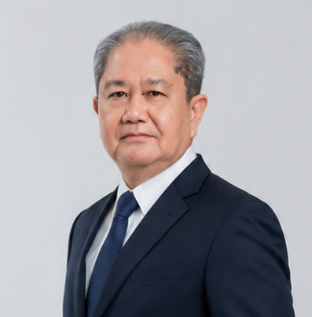

CEZAR P. PUNSALAN, Senior Partner

BS Mechanical Engineering 1971, Mapua Institute of Technology
PME 2648, Registered August 28, 1986
LRPA: 1975 – present
Philippine Society of Ventilation, Air conditioning, and Refrigeration Engineers (PSVARE) Past President
ASHRAE Philippines Chapter Past President
Architectural Centre Club, Inc. (ACCI) Past President
Philippine Green Building Institute (PGBI) Vice President for Finance
Philippine Society of Mechanical Engineers (PSME) Member

Certified HVAC&R Specialist
Specialist # 80715-1-16 (awarded by AHVARSI, 2025)

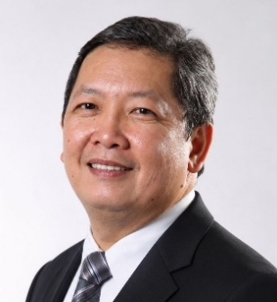

EMMANUEL C. PUNSALAN, Managing Partner

BS Mechanical Engineering 1985, Mapua Institute of Technology
PME 3071, Registered December 1995
LRPA: 1986-present
Association of Heating, Ventilation, Air conditioning, and Refrigeration Specialists, Inc.
(AHVARSI) President
ASHRAE Philippines Chapter Past President, Past Chairman of the Chapters Regional
Conference
Philippine Green Building Initiative (PGBI) Director for Education and Training
Philippine Society of Ventilation, Air conditioning, and Refrigeration Engineers
(PSVARE), Past Treasurer
Philippine Society of Mechanical Engineers (PSME) Life Member
Pambansang Samahan in Inhinyerong Mekanikal (PSIM) Member
Bureau of Product Standards Technical Committee 83 for Cleanrooms (DTI-BSP TC 83)
Member
International Society of Pharmaceutical Engineers (ISPE) Member
Professional Regulation Commission (PRC), Technical Working Group-Mechanical,
Development of the Planning and Design Guidelines for Hospital Facilities
Vice-Chairman
Professional Regulation Commission-Board of Mechanical Engineering (PRC-BME)
Career Progression and Specialization Program (CPSP) Committee Member

Certified HVAC&R Specialist:
Specialist # 80715-1-01 (awarded by AHVARSI, 2025)
Certified Advanced Professional Mechanical Engineer for HVAC&R
AIPO-004 (awarded by PSME 2025)
The Outstanding Mapuan Mechanical Engineer in the field of Consultancy
(awarded by the Mechanical Engineering Graduates Association of Mapua, 2025)

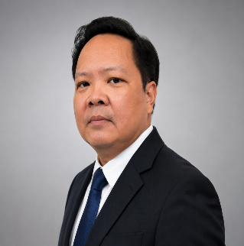

EMELITO C. PUNSALAN, Partner

BS Architecture 1992, University of the Philippines-Diliman
Lic. Arch. 0011313, Registered August, 1993
LRPA: 2005-present
United Architects of the Philippines (UAP) Makati Chapter Member
ASHRAE Philippines Chapter Member
Philippine Green Building Initiative (PGBI), Director for Zero Energy Building (ZEB)
Philippine Green Building Initiative (PGBI), GREEN Building Professional and Assessor
Philippine Green Building Initiative (PGBI), EDGE Reviewer

THE LRPA STRUCTURE
Since the middle of year 2000, LRPA has been adding services to its portfolio. Aside from systems design and consultancy services, more progressive initiatives have expanded the capabilities of the firm in providing multi-faceted services to specific client requirements which will require focused approach.
A new middle management level was established with Engr. Rolex Cabalhin and Engr. John Patrick Baltazar, PME, appointed as Design Group Manager and Building Science Group Manager, respectively. This promotes more efficient and effective design management and better quality control.

THE FACETS OF LRPA

EXPANDED SYSTEM DESIGN SERVICES

To keep pace with increasing industry challenges and evolving building system requirements, LRPA expanded its design services to include electrical and electronics, plumbing and sanitary, and fire protection systems. Partner-consultants who, themselves, are well-established in their specializations team up with LRPA to design MEPF systems for various building typologies and applications.

THE PARTNER-CONSULTANTS
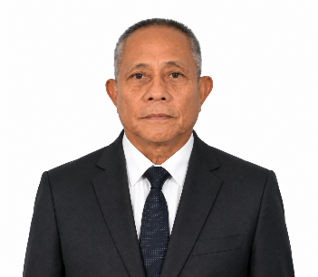

AQUILINO T. RIVERA, Electrical and Electronics Engineering

BS Electrical Engineering 1979, Mapua Institute of Technology,
Professional Electrical Engineer, PEE 2384, registered on April 1990.
Principal: A. T. Rivera Electrical Design Consultancy
Institute of Integrated Electrical Engineers of the Philippines, Inc. (IIEE), Life Member
National Fire Protection Association (NFPA), Member
Illuminating Engineering Society of North America (IESNA), Member
National Association of Mapua Alumni (NAMA)

Outstanding Alumni Awardee in the Field of Electrical Design and Consultancy 2004
(awarded by the Mapua Institute of Technology Electrical Engineers Alumni Association
MITEE-AA)

Industry Experience:

10 years of experience (1980-1990) in manufacturing, testing and commissioning, and servicing of circuit breakers and motor controllers while working with Westinghouse Asia Controls Corporation, a subsidiary of Westinghouse Electric, USA.

36 years of experience in electrical systems design and consultancy services for high-rise buildings, residences, manufacturing and industrial facilities.
1990-1994 Senior Electrical Design Engineer for M.A. Alix and Partners
1994-present Principal of A. T. Rivera Electrical Design Consultancy.
2006-present Partner-consultant with L.R. Punsalan and Associates

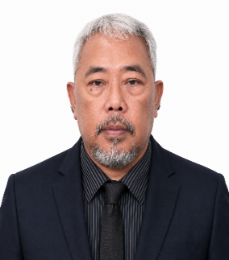

MAXIMO T. ECLEO, Plumbing and Sanitary Engineering

BS Civil Engineering 1991, Mindanao State University
BS Sanitary Engineering 1996, National University
Licensed Civil Engineer, PRC # 65368, Registered November 1992
Licensed Sanitary Engineer, PRC # 1971, Registered September 1997
Career Service Professional, Civil Service Commission, 1992
CEO/Principal: Interflow Innovators, Corporation
Philippine Institute of Civil Engineers (PICE), Member
Philippine Society of Sanitary Engineers (PSSE), Member
National Fire Protection Association (NFPA), Member
American Society of Plumbing Engineers, Associate Member
American Society of Sanitary Engineers, Member

Industry Experience

Two years of experience in civil works involving road works with the Department of Public Works and Highways from 1991-1992

Five years of experience in
Five years of experience in the installation, testing and commissioning, project management of sanitary and fire protection systems with Philsafety System and Safety Equipment Inc. from 1992-1997.

Twenty-eight years of experience in the design and consultancy services for plumbing, sanitary, and fire protection systems for commercial buildings, residences, fit-out projects, manufacturing and industrial facilities.
1997-2000 Assistant Chief Design Engineer for NBF Consulting Engineers
2000-present CEO/Principal Engineer
2000-present CEO/Principal Engineer of Interflow Innovators Corporation
2000-present Partner-consultant for L. R. Punsalan and Associates

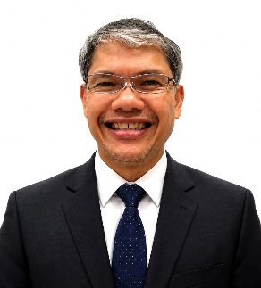

RENATO S. BAUTISTA, Mechanical Engineer for Refrigeration, Steam, CDA)

BS Mechanical Engineering 1987 (cum laude), University of Santo Tomas
Licensed Mechanical Engineer, RMeE 0036257, Registered April 1988

Industry Experience

Thirty years of experience in the manufacturing industry with 28 of those years in the food and beverage manufacturing sector including refrigeration and other utilities.

1987-1988 Integrated Microelectronics Incorporated, Back-end technician
1988-1998 San Miguel Corporation, Design and implementation engineer of the refrigeration, CO₂,
Steam, compressed air, and water treatment systems for the brewery plants
1998-1999 ABS-CBN, Design manager for building utilities
1999-2006 AWS Industrial Corporation (a contracting firm for F&B corporations),
Vice-President for Engineering
2012-2013 Emerson Climate Technologies, Project Design and Service Engineer Lead
2013-2014 Universal Robina Corporation, Project Planning and Design Manager
2000-present Engineering consultant for various food and beverage manufacturing companies for the Design and implementation of utilities for cold storages, and improvements to the Ammonia refrigeration systems. The companies of his involvement as consultant include:

Chowking Food Corporation, commissaries expansion
Red Ribbon Bakeshop Incorporated, commissaries expansion
Northpoint, Inc. (KFC), Ammonia Refrigeration system improvements
M&H Food Corporation (Hen Lin), Rehabilitation of the refrigeration systems
Newly Weds Foods, Expansion of Packaging line
Zenith Foods Corporation (Jollibee), Improvement of ammonia refrigeration plant.
Manila Comisario Central, Inc. (Kuya J), Commissary & cold storage expansion
Fresh and Famous Foods, Inc. (Chowking), Design, and testing and commissioning of Refrigeration and ventilation systems
Far East Machineries Corporation, Design of utilities systems for the ValuePet (PET)

CONTINUING EVOLUTION OF LRPA

LRPA continues to strive for excellence and accuracy as it equips itself with tools for engineering design production, analysis and study, complementing the design services and building science studies.


Building Information Modeling (BIM)




3D Modeling


Computational Fluid Dynamics (CFD)



AutoCAD

Sustainability Analysis Software’s:


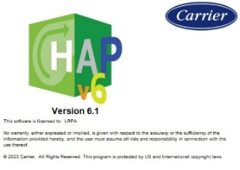
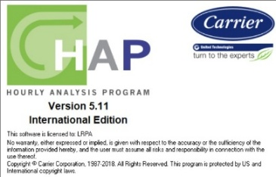

Carrier Hourly Analysis Program version 5.11 and 6.1 EDGE
EDGE Green Building Software

